Test suite of the “Sqrt” program
Input data | Output from the program | Response from Wolfram | Alpha
4 | 2.0 | 2
12 | 3.46 | 3.4641016151
49 | 7.0 | 7
23.5641 | 4.85 | 4.85429
45454.4458 | 213.2 | 213.20048264485706
4.84526684 | 2.2 | 2.201196683624614
0.45125416 | 0.67 | 0.6717545385034626
0 | 0.0 | 0
388.192 | 19.7 | 19.702588662406775
9999999999 | 100000.0 | 99999.9999949999
1) Tests for checking the functionality of finding arithmetic square roots:

2) Tests for checking the functionality of finding complex square roots:

Input data | Output from the program | Response from Wolfram | Alpha
4+2i | 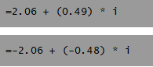 | 2.0581710272 +  0.4858682718i
38-10i | 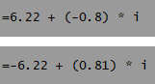 | 6.2166617010 -  0.8042901867i
-0.8344+0.232i | 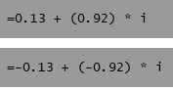 | 0.125803 + 0.922077 i
345535.33+45355.3i | 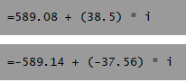 | 589.0818 + 38.49661 i
0+5i | 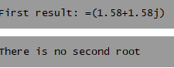 | 1.5811388301 +  1.5811388301 i
454-0.5i | 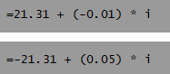 | 21.3072790 -  0.0117330796 i
1-1i | 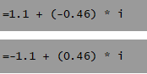 | 1.0986841134 -  0.4550898606 i
23+222i | 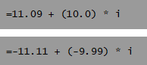 | 11.0947794331 +  10.0047054264 i
-2232.322-864.44i | 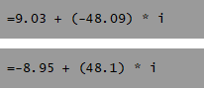 | 8.98688 - 48.0946 i
-0.322-0.44i | 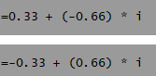 | 0.334094 - 0.658497 i

In total, 10 final tests were carried out for each of the functional sections, as a result of these tests, no errors were identified. The product is ready for release.

